To set up a slave node (agent) in Jenkins using SSH on an AWS EC2 instance, follow these steps:
Prerequisites
- Jenkins Master already installed on an EC2 instance.
- Slave Node (another EC2 instance) with:
  - Jenkins user created
  - SSH access configured
  - Java installed
Step-by-Step Guide
1. Create and Configure the Slave EC2 Instance
- Launch a new EC2 instance (slave) with appropriate specs (e.g., t2.micro).
- Ensure the security group allows inbound traffic on port 22 (for SSH access).
- Install Java on the slave:
sudo apt update # For Ubuntu/Debian
sudo apt install openjdk-11-jdk -y
java -version # Verify Java installation
2. Create a Jenkins User on the Slave Node
- On the slave EC2 instance, create a user for Jenkins:
sudo adduser jenkins
sudo usermod -aG sudo jenkins # Give sudo privileges if needed
- Switch to the jenkins user:
bash
Copy code
su - jenkins
3. Configure SSH Keys for Jenkins Connection
- Generate SSH keys on your Jenkins master instance:
ssh-keygen -t rsa -b 4096 -C "jenkins-slave" # Leave all prompts blank for defaults
- Copy the public key to the slave instance:
ssh-copy-id jenkins@<slave-instance-public-ip>
Alternatively, manually copy the contents of the public key (~/.ssh/id_rsa.pub) and add it to the ~/.ssh/authorized_keys file on the slave node.
4. Configure the Slave Node in Jenkins
- On the Jenkins master web UI, go to Manage Jenkins > Manage Nodes and Clouds > New Node.
- Provide a node name (e.g., "Slave1") and select Permanent Agent.
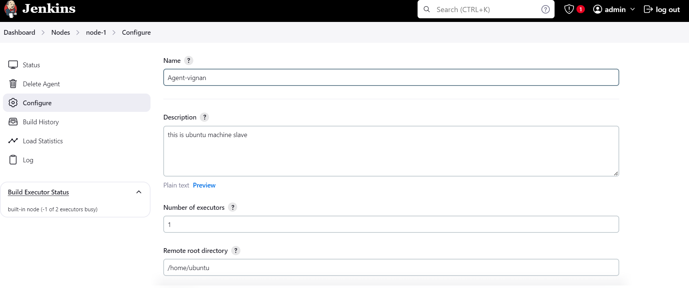

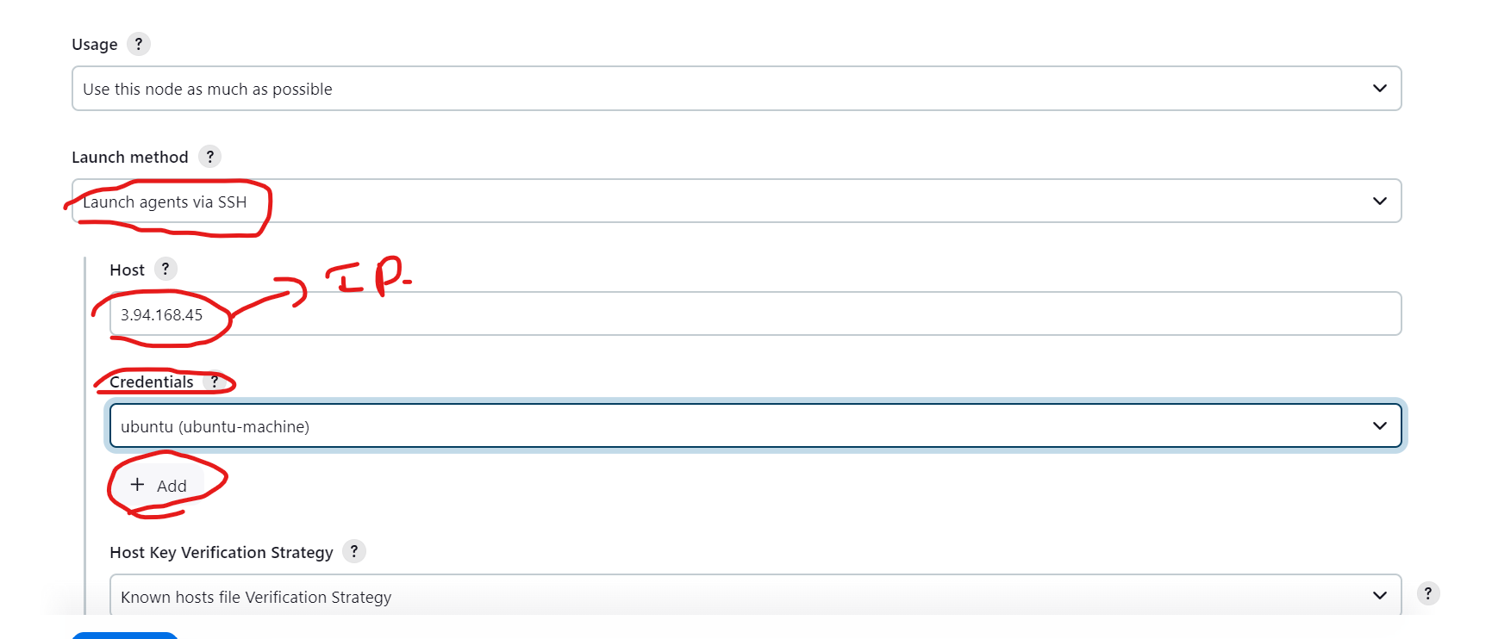

- Configure the following settings:
  - Remote root directory: /home/jenkins (or the home directory of the jenkins user on the slave).
  - Usage: Select the appropriate usage, such as "Use this node as much as possible."
  - Launch method: Choose Launch agents via SSH.
  - Host: Enter the public IP or DNS of the slave instance.
  - Credentials:
    - Add the SSH credentials for the jenkins user. In Credentials, select Jenkins → Add → SSH Username with Private Key.
  - 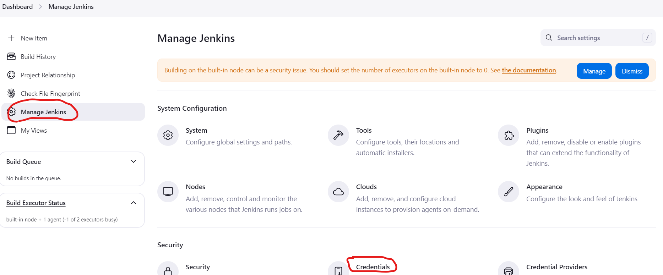
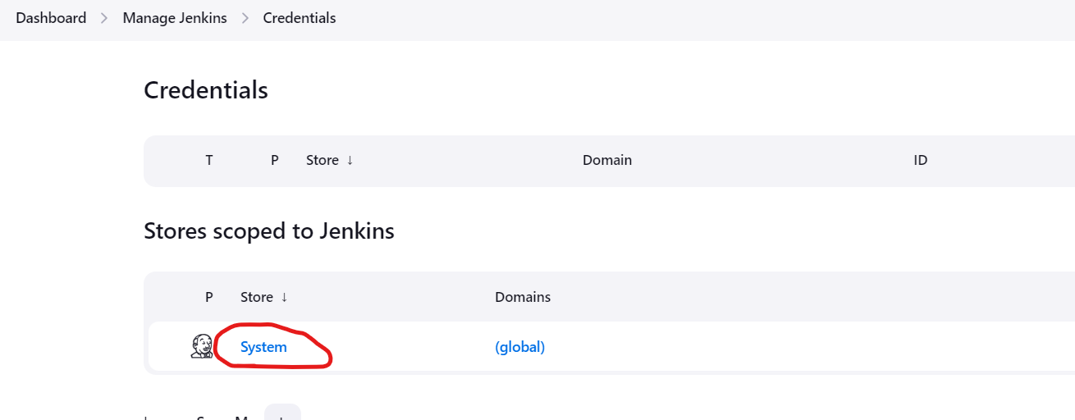
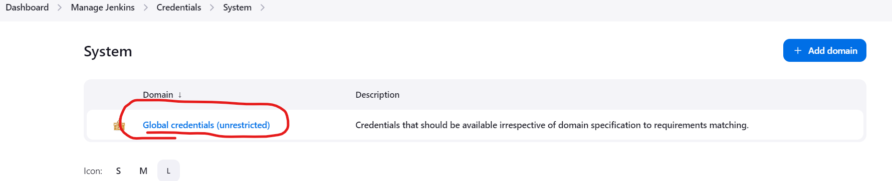

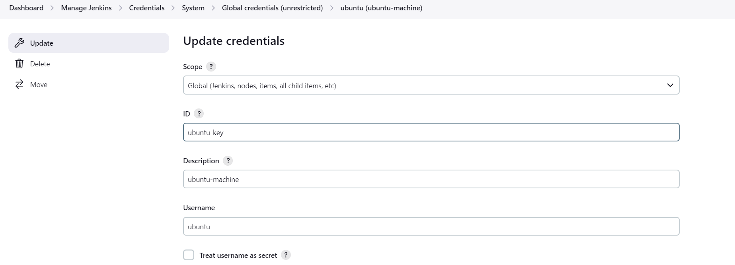
Username: jenkins
    - Private Key: Select Enter directly, and copy-paste the private key (~/.ssh/id_rsa) from the master instance.
  - Host Key Verification Strategy: You can choose "Manually trusted key Verification Strategy" for simplicity.
5. Test the SSH Connection
- Click on the Save button and Jenkins will attempt to connect to the slave via SSH.
- If the connection is successful, the node status will show Online.
6. Verify the Node is Running
- Once the node is set up, it will appear under Manage Nodes with an Online status.
- You can test by configuring a Jenkins job to run on this specific node using the Restrict where this project can be run option (set to the node’s label).
Troubleshooting
- Security Groups: Ensure that the security group of the slave EC2 instance allows SSH (port 22) from the master instance.
- Java: Ensure that Java is installed and correctly configured on the slave instance.
- SSH Key: Ensure that the SSH key permissions on the slave node are set to chmod 600 ~/.ssh/authorized_keys.
This should set up your Jenkins master to connect and use the EC2 slave node for running jobs.

